PIZZA SALES SQL QUERIES
A. KPI’s
1. Total Revenue:
SELECT Round(SUM(ps.total_price),2) AS Total_Revenue
FROM pizza_sales ps;
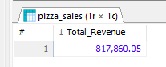
2. Average Order Value
V1.
SELECT COUNT(Distinct ps.order_id) AS Total_noOrders
FROM pizza_sales ps;
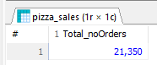
SELECT SUM(ps.total_price) / COUNT(Distinct ps.order_id) AS Avg_Order_Value
FROM pizza_sales ps;
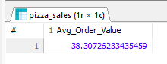
V2. – CTE: Average Order Value / Total Pizzas Sold / Total Orders / Average Pizzas Per Order

WITH calcule AS(
SELECT SUM(ps.total_price) AS Total_Revenue,
COUNT(Distinct ps.order_id) AS Total_noOrders,
SUM(ps.quantity) AS Total_pizzas_sold
FROM pizza_sales ps)

SELECT Total_Revenue,
Total_noOrders,
Total_pizzas_sold,
Total_Revenue / Total_noOrders AS Avg_Order_Value,
ROUND((Total_pizzas_sold / Total_noOrders),2) AS Avg_Pizzas_Per_Order
FROM calcule c;
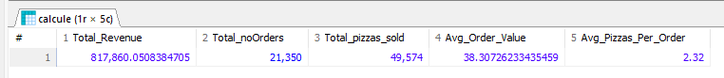
B. Daily Trend for Total Orders
SELECT
DAYNAME(STR_TO_DATE(ps.order_date, '%d/%m/%Y')) AS order_day,
COUNT(DISTINCT ps.order_id) AS total_orders
FROM pizza_sales ps
GROUP BY DAYNAME(STR_TO_DATE(ps.order_date, '%d/%m/%Y'))
ORDER BY total_orders DESC;
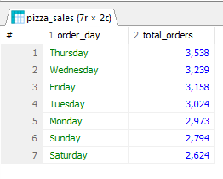
C. Monthly Trend for Orders
SELECT
MONTHNAME(STR_TO_DATE(ps.order_date,'%d/%m/%Y')) AS order_month,
COUNT(DISTINCT ps.order_id) AS total_orders
FROM pizza_sales ps
GROUP BY MONTHNAME(STR_TO_DATE(ps.order_date,'%d/%m/%Y'))
ORDER BY total_orders DESC;
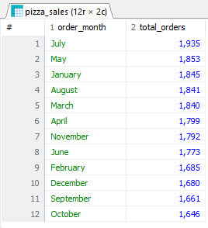
V2 – sort by first month of year
SELECT
MONTHNAME(STR_TO_DATE(ps.order_date, '%d/%m/%Y')) AS order_month,
COUNT(DISTINCT ps.order_id) AS total_orders
FROM pizza_sales ps
GROUP BY
MONTHNAME(STR_TO_DATE(ps.order_date, '%d/%m/%Y')),
MONTH(STR_TO_DATE(ps.order_date, '%d/%m/%Y'))
ORDER BY MONTH(STR_TO_DATE(ps.order_date, '%d/%m/%Y')) ASC;
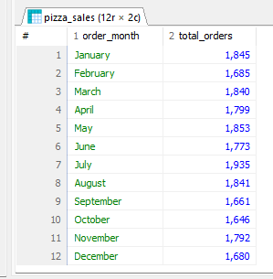

**verificarea pozitiei zilei / lunii intr-o info de tip data:
SELECT order_date
FROM pizza_sales
WHERE CAST(SUBSTRING_INDEX(order_date, '/', 1) AS UNSIGNED) > 12
LIMIT 5;
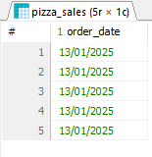
D. % of Sales by Pizza Category
WITH sales_per_category AS(
SELECT ps.pizza_category, SUM(ps.total_price) AS total_revenue_categ
FROM pizza_sales ps
GROUP BY ps.pizza_category),

total_gen AS(
SELECT SUM(ps.total_price) AS total_revenue
FROM pizza_sales ps)

SELECT spc.pizza_category,
Concat(ROUND((total_revenue_categ / total_revenue)*100,2),'%') AS '% of total sales'
FROM sales_per_category spc
CROSS JOIN total_gen;
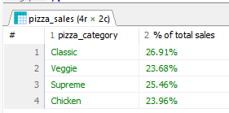
V2 – cu filtrare pe o anumita luna (!Atentie: WHERE se aplica in interiorul fiecarui CTE):

WITH sales_per_category AS (
SELECT ps.pizza_category, SUM(ps.total_price) AS total_revenue_categ
FROM pizza_sales ps
WHERE MONTH(STR_TO_DATE(ps.order_date, '%d/%m/%Y')) = 1
GROUP BY ps.pizza_category
),
total_gen AS (
SELECT SUM(ps.total_price) AS total_revenue
FROM pizza_sales ps
WHERE MONTH(STR_TO_DATE(ps.order_date, '%d/%m/%Y')) = 1
)
SELECT
spc.pizza_category,
CONCAT(ROUND((total_revenue_categ / total_revenue) * 100, 2), '%') AS `% of total sales`
FROM sales_per_category spc
CROSS JOIN total_gen;
- Filtrare pe Luna ianuarie -
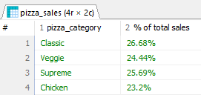
- Filtrare la nivel de trimestru -
WITH sales_per_category AS (
SELECT ps.pizza_category, SUM(ps.total_price) AS total_revenue_categ
FROM pizza_sales ps
WHERE QUARTER(STR_TO_DATE(ps.order_date, '%d/%m/%Y')) = 1
GROUP BY ps.pizza_category
),
total_gen AS (
SELECT SUM(ps.total_price) AS total_revenue
FROM pizza_sales ps
WHERE QUARTER(STR_TO_DATE(ps.order_date, '%d/%m/%Y')) = 1
)
SELECT
spc.pizza_category,
CONCAT(ROUND((total_revenue_categ / total_revenue) * 100, 2), '%') AS `% of total sales`
FROM sales_per_category spc
CROSS JOIN total_gen;
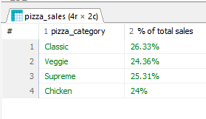

E. % of Sales by Pizza Size
WITH sales_per_pizzaSize AS(
SELECT ps.pizza_size, SUM(ps.total_price) AS total_revenue_categ
FROM pizza_sales ps
GROUP BY ps.pizza_size),

total_gen AS(
SELECT SUM(ps.total_price) AS total_revenue
FROM pizza_sales ps)

SELECT spc.pizza_size,
Concat(ROUND((total_revenue_categ / total_revenue)*100,2),'%') AS '% of total sales'
FROM sales_per_pizzaSize spc
CROSS JOIN total_gen
ORDER BY total_revenue_categ DESC;

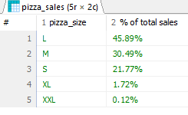
F. Top 5 best-selling pizzas by revenue, total quantity & total orders
SELECT ps.pizza_name,
Round(SUM(ps.total_price),2) AS Revenue,
SUM(ps.quantity) AS Total_Quantity,
COUNT(DISTINCT ps.order_id) AS Total_orders
FROM pizza_sales ps
GROUP BY ps.pizza_name
ORDER BY Revenue DESC,Total_Quantity DESC,Total_orders DESC
LIMIT 5;
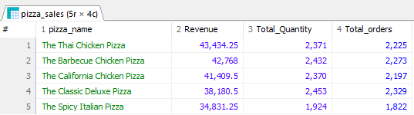
-- top 5 worst-selling pizzas by revenue, total quantity & total orders
SELECT ps.pizza_name,
Round(SUM(ps.total_price),2) AS Revenue,
SUM(ps.quantity) AS Total_Quantity,
COUNT(DISTINCT ps.order_id) AS Total_orders
FROM pizza_sales ps
GROUP BY ps.pizza_name
ORDER BY Revenue ASC,Total_Quantity ASC,Total_orders ASC
LIMIT 5;
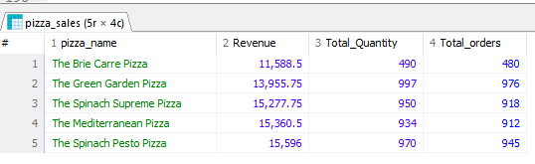

- V2
(SELECT
'Top 5' AS type,
ps.pizza_name,
SUM(ps.total_price) AS Revenue,
SUM(ps.quantity) AS Total_Quantity,
COUNT(DISTINCT ps.order_id) AS Total_orders
FROM pizza_sales ps
GROUP BY ps.pizza_name
ORDER BY Revenue DESC
LIMIT 5)

UNION ALL

(SELECT
'Bottom 5' AS type,
ps.pizza_name,
SUM(ps.total_price) AS Revenue,
SUM(ps.quantity) AS Total_Quantity,
COUNT(DISTINCT ps.order_id) AS Total_orders
FROM pizza_sales ps
GROUP BY ps.pizza_name
ORDER BY Revenue ASC
LIMIT 5);
